Ian’s HOR hopup guide rev8
Radio Control Motorcycles of California
http://rcmcc.tripod.com

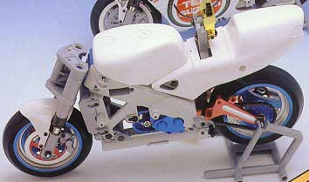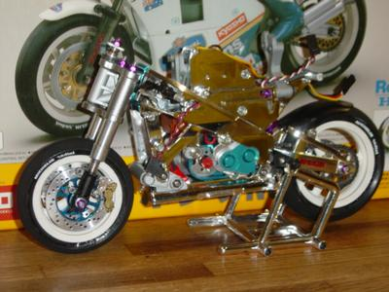

Disclaimer:
Really, the point of this guide is to make it clear on what each hopup does to the bike and give indications on what to look out for when using them. Please keep in mind these are just my own personal opinions. I am in no way saying that the bike in stock form is inadequate – in fact I recommend you run the bike 100% stock the first time you build one. The bottom line is, these “K-bikes” are a blast in all regards! Have fun!

Changes to rev8: Moved mods around the categories, changed descriptions a little bit.
Note: The items I currently use are highlighted in green.

HIGH priority list hopups:
- Kyosho 28BB Grand Prix Motor (or any 280 and up sized motor): Makes a huge difference over the kit motor. 300 size motors work great too but you will need a mounting adapter for the wider bolt pattern. Use resistors for these. Brushless systems (i.e. Mamba) are the fastest motors available. Mamba review
Screw sizes: 180-size: 2mm, 280-size: 2.6mm, 300-size: 2.6mm w/adapter or 3mm w/o adapter
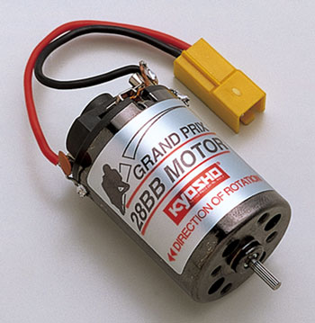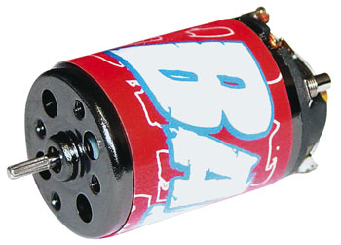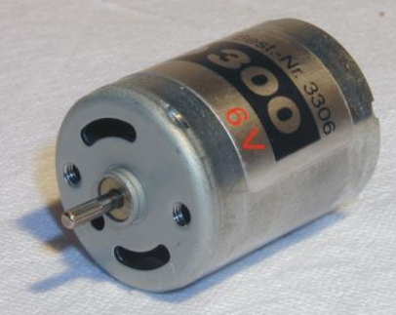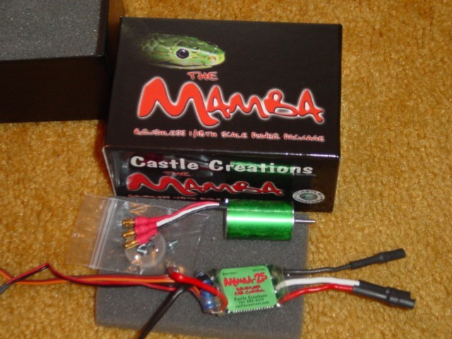
- TOPCAD/Dinball/Boca ball bearings: Kit bushings create too much friction. Spray them with motor spray to clean them and give them a drop of bearing oil every so often. For the kit plastic gearbox, the flanged bearings may not fit.
Sizes: Bearings for gearbox: 3 x 6 x 2.5 mm flanged, Bearings for wheels: 5 x 10 x 4 mm non-flanged
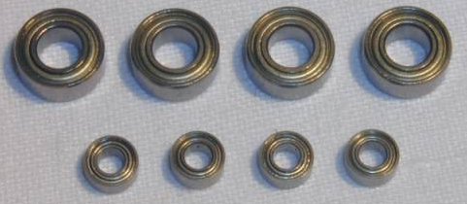
- 1050+mAh 7.2V NiMH battery: Higher power output and longer run times. 7.2V NiMH GP1100’s are great. Charge NiMHs & NiCDs at 1.5A. 2S and 3S Lipos can be used, but you will need a special charger and ESC w/ voltage cutoff to prevent damaging the cells.
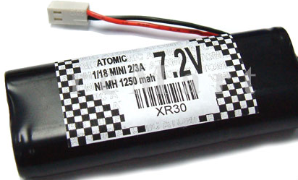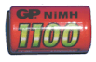

- Silicone front molded insert: Simulates front tire air pressure, which makes turning more responsive at higher speeds. Use a two-part silicone mix for this and inject w/syringe into a cutout hole in an empty tire assembly. There are two types: flywheel version and one full insert for no flywheel. Flywheel version creates better stability at slower speeds but w/slower steering response (but still way better than w/o this insert). Vice versa for other version. Foam is not as good for the front because it doesn’t fill up all the gaps (especially the sidewalls) like silicone molds do and also because foam is much lighter, creating front end wobbles.
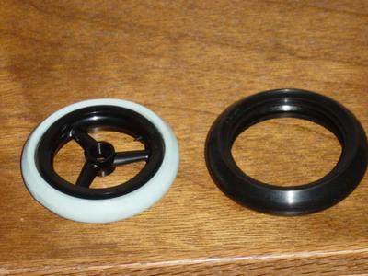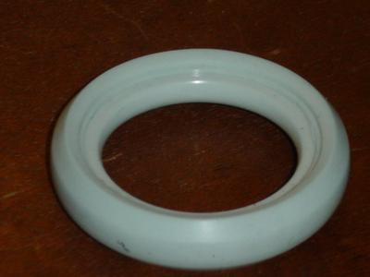
- Kyosho light wt. flywheel: Use for the flywheel version silicone insert. Kit iron flywheel is too heavy for handling. Can use foam instead of silicone with this flywheel, since the metal gives you the much needed front weight. However as mentioned before, silicone is your best option with this.
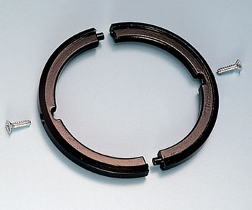
- Rear hard foam insert: Use Home Depot/Lowes ½”D door weather sealer for the rear. Silicone inserts work well with the rear in regards to stability but are heavier and stiffer. You want this tire to have a little “give” because it is put under much more stress (i.e. accelerating/braking) than the front tire.
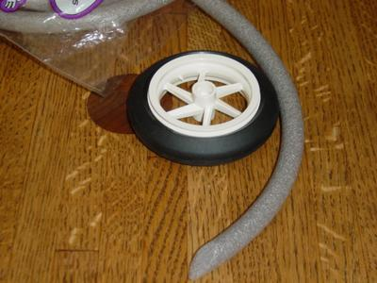
- Epoxy crash bar mounts: When you look at the rear crash bar mounts, you realize that these sections are too thin. They crack immediately after a hard side landing on the crash bars. Beef the back sides up with 3/8” of epoxy. With my first frame I didn’t do this and the sections cracked after some wicked crashes (and I didn’t notice until I dissected the bike). Now this is a must do for all my frames.
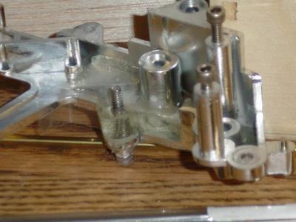
- TOPCAD/GPM oval washers for gearbox: Beefs up tranny case mounts, and with it you can fully tighten the tranny case mounting screws to keep the chain tension tight. Important because if the chain tension ever gets loose it can damage the whole drive train with one pull of the accel. trigger.
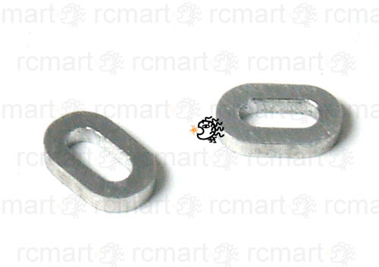
- Kyosho steel gearset: No improvement in performance but in crashes they are less likely to break. Essential in my book if you plan on running with the faster motors. I use a metal pinion with the middle idler gear and rear sprocket, but use the kit plastic drive sprocket so if the gearbox hangs up it breaks for protection.
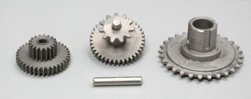

MEDIUM priority list hopups:
- Kyosho/TOPCAD/GPM rear oil shock: Smoothes out the bounciness of the stock undamped spring shock. Fill them with 60wt. oil. With the Kyosho oil shock you can change spring preload while installed on the bike using the bottom dial. I don’t usually tune with preload though. Rather, I use springs for the Associated TC3.
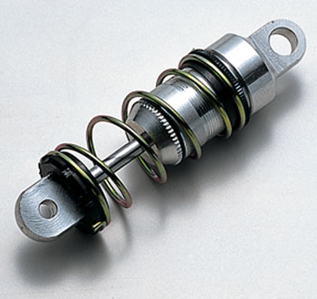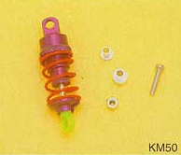
- Kyosho SP steering parts: Pretty crappy for what you pay for but the larger 4.1mm shaft has no play and the friction spring reduces triple clamp wobbling. Definitely worth it for these hard to find parts. Important if you plan on running the front tire w/o any metal flywheel installed.
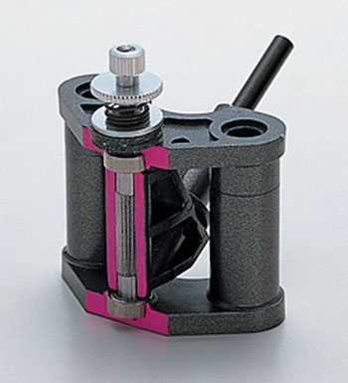
- TOPCAD/GPM alum. gearbox: More rigidity makes a cleaner mesh for the gears. Also, this is a great heatsink for the motor. Cut a slot on the lower left for easier pinion access.
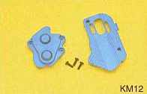
- Aftermarket metal pinions: Nowadays everyone makes micro setscrew-type metal pinions, like HPI (micro RS4) and Team Associated (for the 18T). These are very reliable and easier to install (see gearbox slot above to help) than the plastic press fit pinions. 8-9T pinions are good for wheelies, 11-13T are good for precise riding, and 15T pinions are for all out speed.
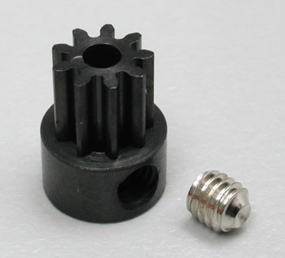

- TOPCAD/GPM alum. front discs (TOPCAD fits tighter than GPM): They center the front wheel very snugly and won’t warp. They also have less friction than using the kit plastic discs (but if you use GPM alum. axle carriers use the plastic discs to avoid metal-to-metal friction, as this will create side-to-side play over time). What I do instead though is put the bearings in the wheel and machine axle spacers to get rid of using discs.
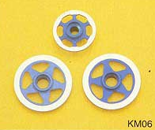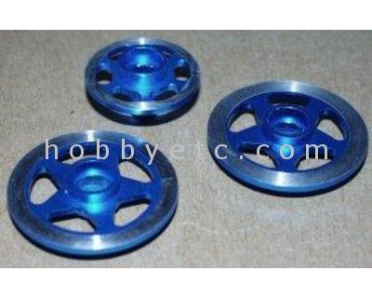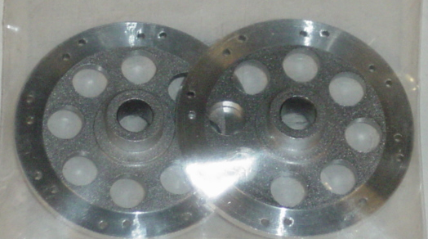
- Kyosho high grip tires: The high grip rear tire will make a big difference in overall grip. The front high grip tire doesn’t help grip much, and because the profile is less aggressive than the kit tire, I use the kit front tire for faster handling. Throw away the included soft foam inserts and refer to #4 and #6 above. Note: these tires have a wider profile than stock, so you may have to dremel the insides of the mudguards and/or front forks in order to fit.
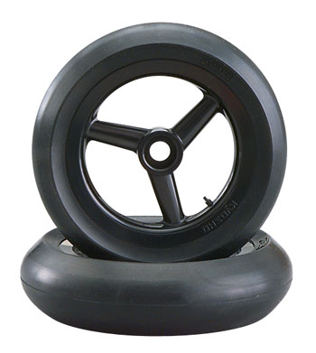
- Crash bar mod: Lengthens the crash bar lengths so that you can corner cleanly at full lean. You must make your own bars but you get the freedom of setting your own lean angle. Set them to the point where the bottom fairing barely rubs at full lean - if the fairing scrapes too much you can’t turn as tight. Two ways to do this: pic 1) get 4-40 setscrew wing mounts, threadlock ¾” 4-40 setscrews into them, and thread into the frame. Then bend 3/32” music wire into the wing mounts; pic 2) bend 3/32” music wire into the stock crash bar shapes but a little longer.
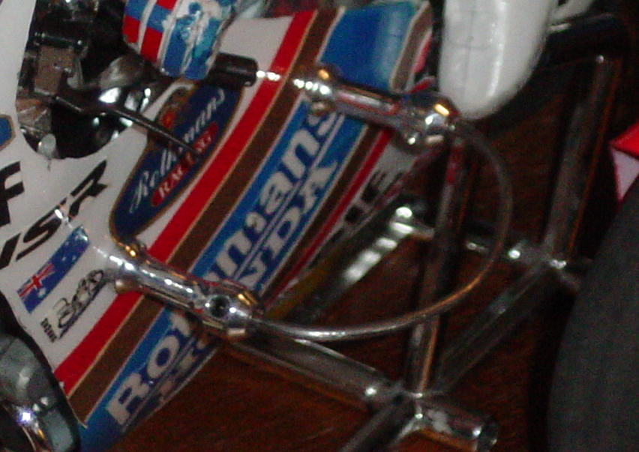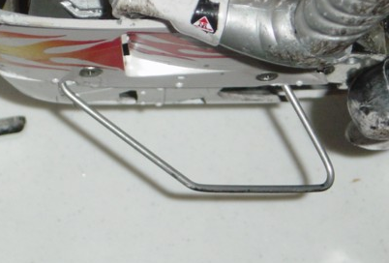
- GPM alum. oil forks: Much smoother action than the plastic forks. However, they leak oil no matter which oil wt. you use, so there is really no added damping. The GPM alum. front axle carriers are quite nice, however be aware of the metal-metal wear if you plan on using the metal front discs.
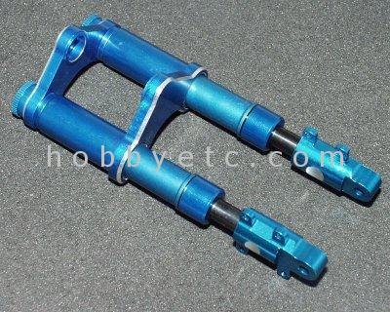
- Kyosho alum. oil forks: see above
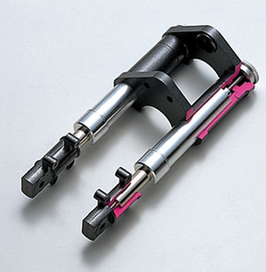

LOW priority list hopups (but still neat to have):
- TOPCAD/GPM alum. swingarm (TOPCAD OBSOLETE): Nice because you can swap out the rear shock without having to dismantle the frame. May have to file inner left side for chain clearance. Shave out the anodized hole so the frame swivel shaft can fit through easily. This is more of a “bling bling” part in my opinion, unless you like to swap out rear shocks frequently. Note: since the axle mounts are rigid, in a hard crash the force gets transferred to the plastic wheels, which can crack.
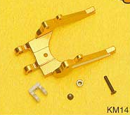
- TOPCAD/GPM rear disc (TOPCAD OBSOLETE): No big advantage to using the rear disc, but the disc trueness is a plus. The GPM disc is loose when fitting into the rim. Put tape on the shaft to shim it in tightly. TOPCAD fits snug, but it protrudes out more.
- Hex head screw set (of various lengths): Phillips heads are not very serviceable heads. Try to replace all self tapping screws with 4-40/2-56 hex head screws and all other screws with hex head. Must use a 4-40/2-56 drill and tap first on the plastic parts. Very handy when you constantly dismantle and work on your bike, because hex drivers don’t need vertical force to drive in screws, and they can fit in very tight places. Plus, self tapping screws can split plastic parts if tightened too much. Note #1: It is a good idea to use plastic screws (hard to find in hex head) to mount the windshield onto the front cowling, because in crashes metal screws can rip the windshield right off. Note #2: rcscrewz.com sells hex head screws as well for the bikes, however they are self tapping like the kit screws.
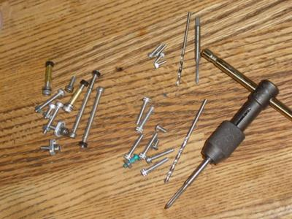
- GPM/TOPCAD alum. triple clamps (TOPCAD OBSOLETE): Great for looks, but the bottom clamp doesn’t secure on in the TOPCAD version. Shoo Goo the bottom clamp to the stanchions to hold them in place.
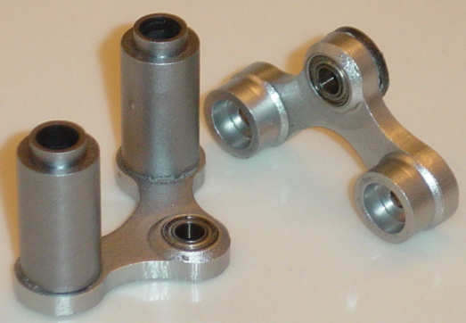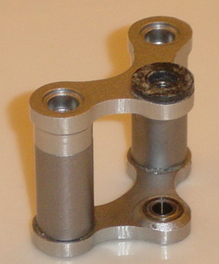
- GPM alum. rims: These are too heavy to run competitively using 180, 280, or even 300-size powered bikes due to the increased weight/power ratio. If you’re prone to hard crashes, they could help you in terms of rim durability but they transfer the force to break something else anyway. However where power is not an issue as with the tuned 300’s or brushless motors, I’ve found that with the heavier rims the bike is more stable. In particular, with the rear alum. rim installed (the front rim has a flywheel built-in so I don’t use it) the bike was more stable during braking because with the added weight in the back it fishtailed less. Note: stock and GPM front discs fit in the GPM front rim, but TOPCAD discs don’t. Same exact thing with the stock, GPM, and TOPCAD rear discs and sprockets, however the Kyosho option steel sprocket doesn’t fit either.
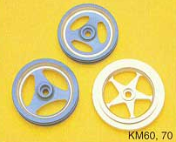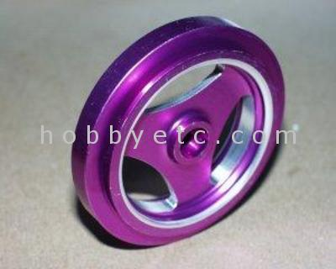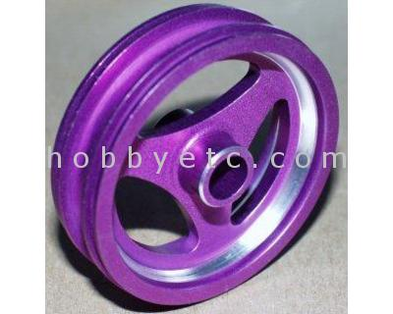
- Kyosho plated frame: It looks great but it is more brittle than the kit frame and harder to modify due to the chrome coating. For looks, but I still use it. Make sure you sand the chrome off before modifying.
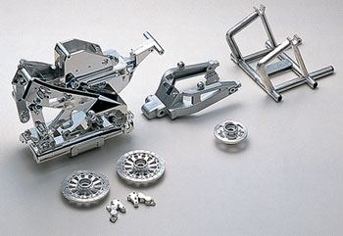
- Kyosho special heat sink: Does the job well, but this is a lot of added weight to tack on. No big benefit to using this on 280-sized motors and below unless your motors always run hot to the touch. For the brushless motors, definitely use it – they put up so much power that the added weight doesn’t make a difference (actually with hotter motors, more weight is better!).
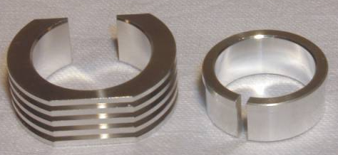
- TOPCAD slipper clutch rear sprocket (OBSOLETE): OK, so I haven’t tried it yet (they were discontinued when I wanted one). They are neat though, with a setscrew used to control the amount of slippage.
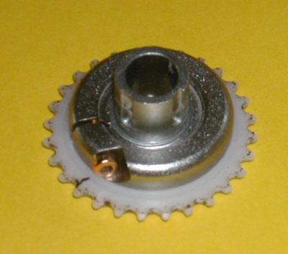

NOT RECOMMENDED hop ups:
- GPM alloy drive stand: First of all, the plastic stand never breaks, so this doesn’t add to strength. Also, it doesn’t add much to the aesthetic factor because you can’t see it when installed. Plus, because some of the dimensions are off and some of the features are missing, it is tough to install correctly and get the rider joints to not bind on the stand. Reviewed here: rcgroups article
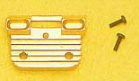
- Kyosho/GPM hard pinion set: Difficult to fully tighten the small tiny setscrew. Also, there have been reports that the teeth break off in big crashes. Use the press fit 12T-14T kit plastic ones instead, or aftermarket setscrew metal pinions.
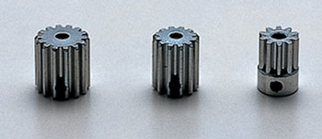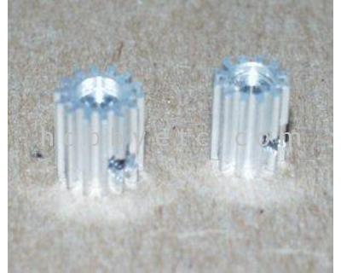
- GPM alum. gearset: Better than the stock plastic gearset but I recommend using the Kyosho steel gearset instead for the lethal lipo-brushless combination. These are made of aluminum, so they tend to wear each other out quick.
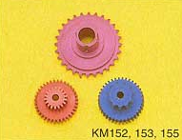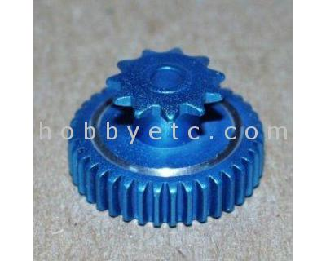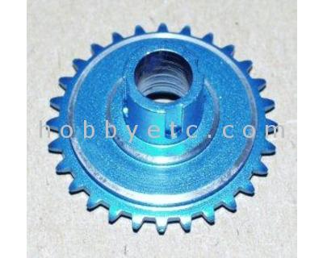
- GPM bearing steering block: It takes a bit to install cleanly with little performance gain. Shortens wheelbase, so lower fairing will drag the ground at full lean (because of this I prefer to use the kit plastic steering block instead). Also visually the bike looks a bit different with the shorter wheelbase.
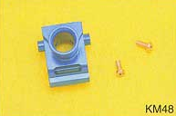

Sources:


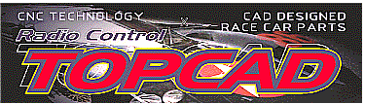




Thanks for reading this tech article!


